# DEPARTMENT OF Computer SCIENCE AND ENGINEERING



**CERTIFICATE**

This is to certify that the Database Management System Project work entitled **“BLOODBANK AND DONOR MANAGEMENT SYSTEM”** has been carried out by **VIJETHA (1KS18CS117)** and **SUSHMITHA (1KS18CS106)** bonafide students of **KS Institute of Technology** in partial fulfillment for the award of **Bachelor of Engineering** in **Computer Science and Engineering** of the Visvesvaraya Technological University, Belgaum during the year **2020-2021**. It is certified that all corrections/suggestions indicated for Internal Assessment have been incorporated in the Report deposited in the departmental library. This DBMS Project Report has been approved as it satisfies the academic requirements in respect of project work prescribed for the said degree.

**----------------------- ----------------------**

**Signature of Guide Signature of HOD**

**Mr. Kumar K Dr. Rekha B Venktapur**

**Associate Professor Professor, Head**

**Dept. of CSE, KSIT Dept. of CSE, KSIT**

**ACKNOWLEDGEMENT**

We would like to thank our Guide, Mr. Kumar K and Mr. Prashanth H for their aid and evaluation over the course of completion of this project. We would also like to thank our University, Visvesvaraya Technological University for the opportunity to make this project which has given us the chance to learn about these topics. Additionally, we would like to thank our college, K S Institute of Technology for allowing us to use the college resources. Finally, I would like to thank our friends and family for their ceaseless and tireless support throughout this project.

**CONTENTS**

Abstract

List of tables

1. Chapter 1: Introduction…………………………………………………….....
2. Chapter 2: Software Requirement Specifications…………………….........
3. Chapter 3: Design…………………………………………….............................

3.1. ER diagram…………………………………………………………..............

3.2. Schema diagram……………………………………………………...............

3.3. Use Case Diagram

4. Chapter 4: Implementation……………………………………………….......

5 Chapter 5: Results snaps…………………………………………………….........

6 Chapter 6: Conclusion. ……………………………………………………........

* 1. Conclusion………………………………………………………………....

**ABSTRACT**

Problem statement

Now we are living in new generation and facing a problem is not a big issue, but for getting a solution of that problem is a challenge of a person. Here, one of the major problem is getting the blood and donating the blood. By, using this Application people can save their time they don’t need to go or search whole city. They can get all the information regarding the blood group, donor and easily reach there and save time.

Objective

• To facilitate the search process for needy people and make it easier than before .

• Some blood groups are rare so the system can find the required donors with the required blood type easily from the huge database by using search feature in the android application.

Techniques

The project is mainly based on MySQL database a web application to be developed in PHP. Result This project monitors all the information about blood donor and updates it frequently.

Concluding statement

The proposed system can be used to reduce the time required to deliver required blood to the needy in cases of emergency.

**LIST OF TABLES**

* admin
* tblblooddonars
* tblbloodgroup
* tblcontactusinfo
* tblcontactusquery
* tblpages

**Chapter 1**

**Introduction**

* 1. **Introduction**

Blood is necessary element in the human body .Without blood, the human body is incomplete. Blood is about 7% to 8% of human weight, according to scientists. Blood is donated in the conventional way by blood donation services or blood bank. Blood bank is defined as an area where blood is obtained as a result of donor blood operation that is processed and preserved for subsequent transfusion.

**Overview**

The proposed Blood Bank Application helps the people who are in need of a blood by giving them all details of blood group availability or regarding the donors with the same blood group. They don’t need to go anywhere to search the blood when they need. They just need to use this Application then all the result will appear in just a second.

Our life is so busy so we don’t have time to spend going here and there, we can use technical way to search the blood by using the Blood Bank Application we can find thousands of people who are donating the blood and also get the detail of that person that in which city he belongs to and what is the Blood group of that person. So this is the most useful Application ever.

**Objective**

To facilitate the search process for needy people and make it easier than before.

Some blood groups are rare so the system can find the required donors with the required blood type easily from the huge database by using search feature in the application.

**Scope**

Blood Bank Application is usually designed for the people who are needed to donate the blood or those who needed to get blood.

All the information will provide in this application like Blood group, Donor information.

If any person want to donate the Blood so he need to get the registration than he will be able to donate the blood and become a member of this.

**Problem Definition**

Now we are living in new generation and facing a problem is not a big issue, but for getting a solution of that problem is a challenge of a person. Here one of the major problem is getting the blood and donating the blood. By using this Application people can save their time they don’t need to go or search whole city. They can get all the information regarding the blood group, donor and easily reach there and save time.

**Chapter 2**

**Software Requirements Specification**

**2.1. Software Requirements Specification**

Language used: PHP

Database: MYSQL

Software used: XAMPP

Server User Interface Design: HTML, AJAX , JQERY, JAVASCRIPT

Web Browser  :  Google Chrome

**2.2 Hardware Requirements**

RAM:512MB and above

Hard disk:35GB or above

Output devices: Monitor

Input Devices: keyboard, mouse

**Proposed methodology**

Front end

• Admin login This is a JavaScript login page. In the code we perform Ajax request to match admin email and password for login.

• Add Blood Group This is add blood group page where admin can add blood group.

• Add donor section in the page admin can add donor information. He has to write

name, mobile no, email id, age, blood group, address, message and also must be selected

the donor’s gender.

• Manage Blood Group In this section, here the page means manage blood group. Here

admin can manage the groups of blood. Admin can also delete the blood group.

• Donor List This layout admin can see the donor list. Admin can also delete the donor bio

from the list. Admin can also download the donor list .

• Become a Donor In this section, anyone can be a donor. For this he/she should fill up the

donor form. he/she must add name, mobile no, email, age, blood group, address, message,

and also select the gender.

• Dashboard In this section admin can see the listed blood groups, registered blood group, and

total queries.

**Process Description**

**Name of the modules**

• Donor module

• Blood stock module

• Blood module

**Description**

**Donor module:**

The main objective for developing this module is provide all we have developed all type of Create, Read, Update and Delete operations of the donor. This is a role based module where admin can perform each and every operations on data.

**Features of Donor Module:**

• Admin can add new donor.

• Admin can see the list of donor details.

• Only admin can edit and update the record of the donor.

• Admin will be able to delete the records of the donor.

**Blood Stock Module:**

The main aim of this module is to provide all the functionality related to blood stock. This blood stock module is an important module in this project Blood Bank Management System which has been developed on PHP and MYSQL. So that all blood stock will be managed by admin and user will be able to see blood stock. It tracks all the information and details of the blood stock.

**Features of Blood Stock Module:**

• Admin can add new blood stock.

• Admin can see the list of blood stock details.

• Only admin can edit and update the record of the blood stock.

• Admin will be able to delete the records of the blood stock.

**Blood Module:**

The main aim of this module is provide to all the functionality related to blood. It tracks all the information and details of the blood.

**Features of Blood Module:**

• Admin can add new blood. • Admin can see the list of blood details.

• Only admin can edit and update the record of the blood.

• Admin will be able to delete the records of the blood.

**Functionality performed by Admin user:**

• Login for Admin

• Forgot password for admin

• Edit profile for admin

• Change password for Admin

• Logout Functionality

• Dashboard for admin user

**Manage Blood**

• Edit the existing blood

• View details of the blood

• Listing of all blood

**Manage Blood Stock**

• Adding New Blood stock

• Edit the existing Blood Stock

• View details of the Blood Stock

• Listing of all Blood Stock Manage Donor

• Adding New Donor

• Edit the Existing Donor

• View details of the Donor

• Listening of all donors

**Chapter 3 Design**

**3.1. E R Diagram**

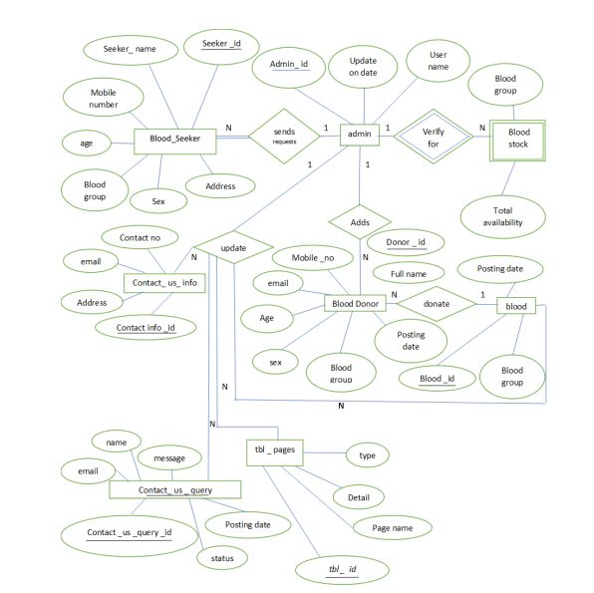

**3.2. Schema Diagram**

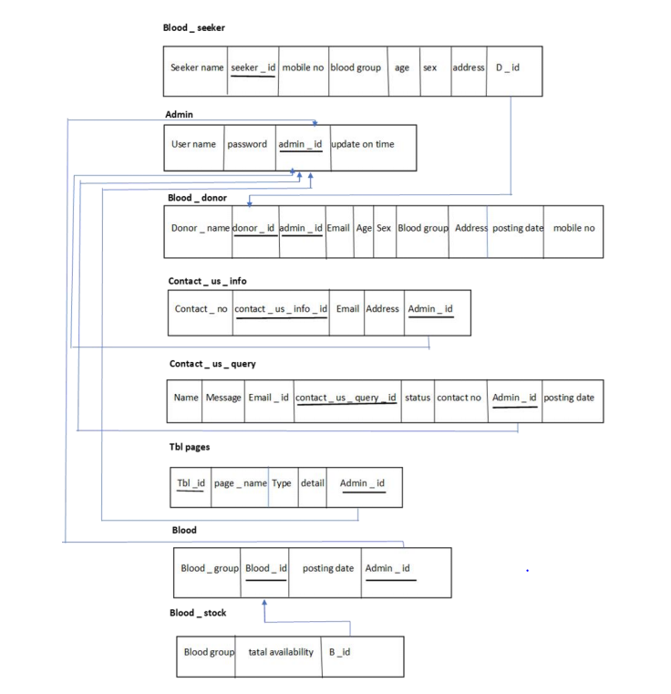

**3.3. Use Case Diagram**

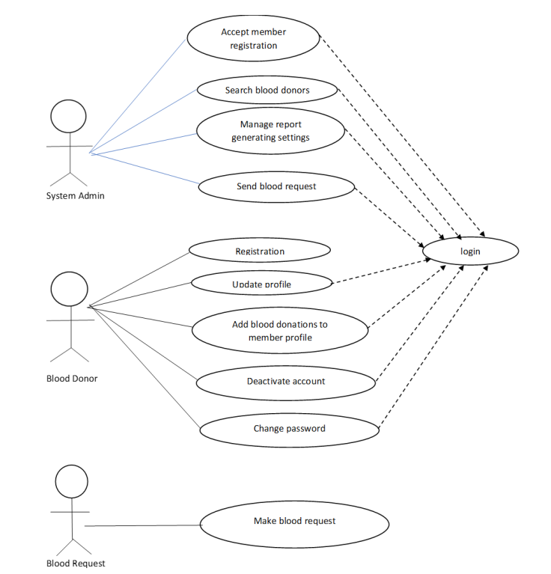

**Chapter 4**

**Implementation**

**4.1. Implementation**

The project is implemented in HTML, Php and CSS for Front-End (website) and MySQL for Back-End (database). It has a three-tier architecture with Front-End forming Application Layer and Back-End forming Middle Layer and Database. Input validation is done in Php. Php communicates with the local server. The server responds with HTML code that is then displayed on the Front-End. The server communicates with MySQL using connect.

**4.2. Programming Language Selection**

Php was used to communicate with MySQL because PHP is the most popular scripting language for web development. It is free, open source and server-side (the code is executed on the server). MySQL is a Relational Database Management System (RDBMS) that uses Structured Query Language (SQL). It is also free and open source. The combination of PHP and MySQL gives unmet options to create just about any kind of website - from small contact form to large corporate portal.

HTML and CSS is used for the front-end as it versatile and easy to use.

**4.3. Description of tables**

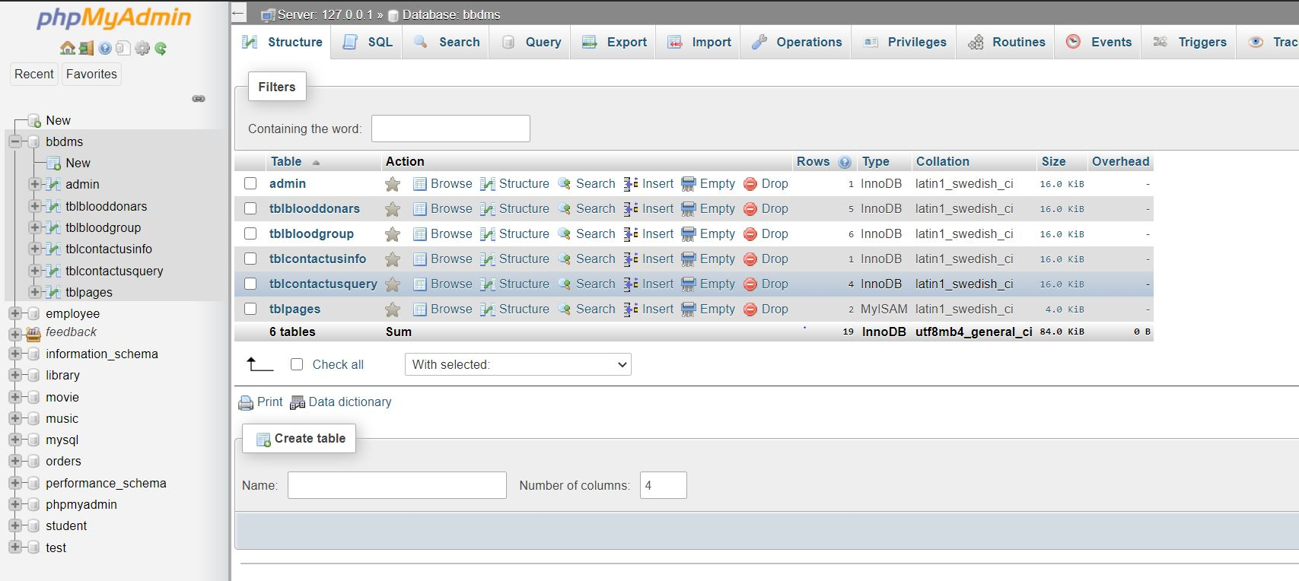

**Admin:**

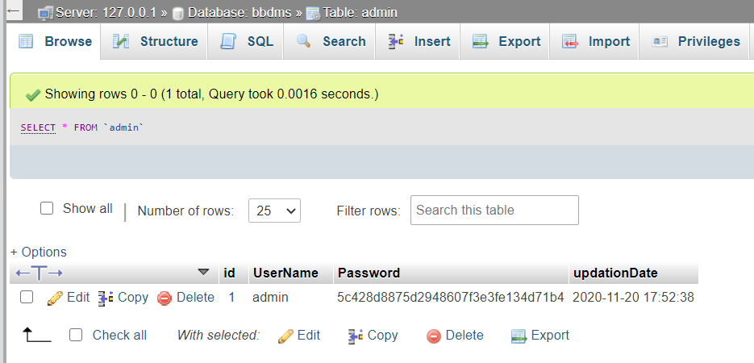

**Tblblooddonars:**

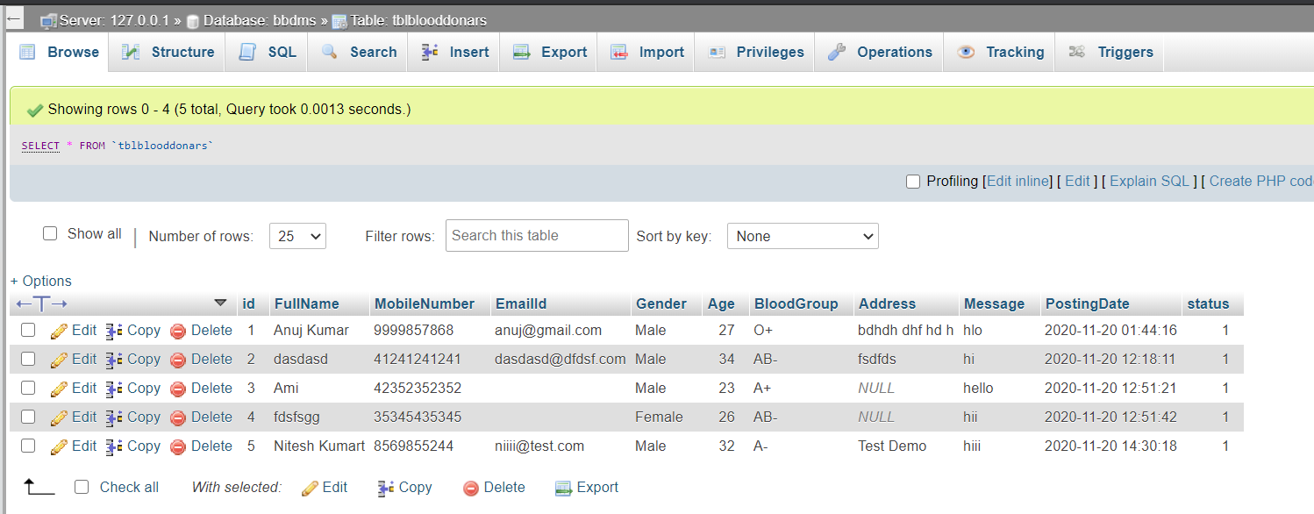

**Tblbloodgroup:**

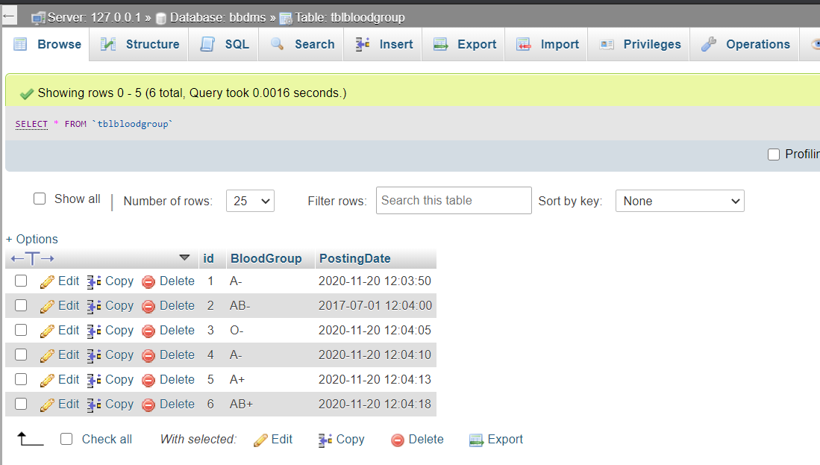

**:**

**Tblcontactusinfo:**

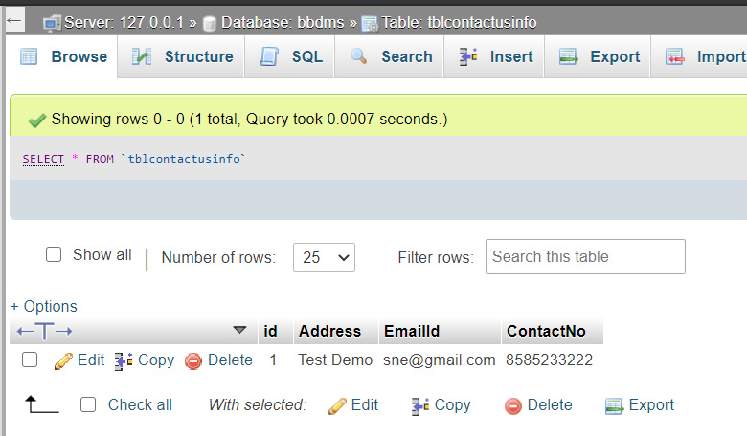

**Tblcontactusquery:**

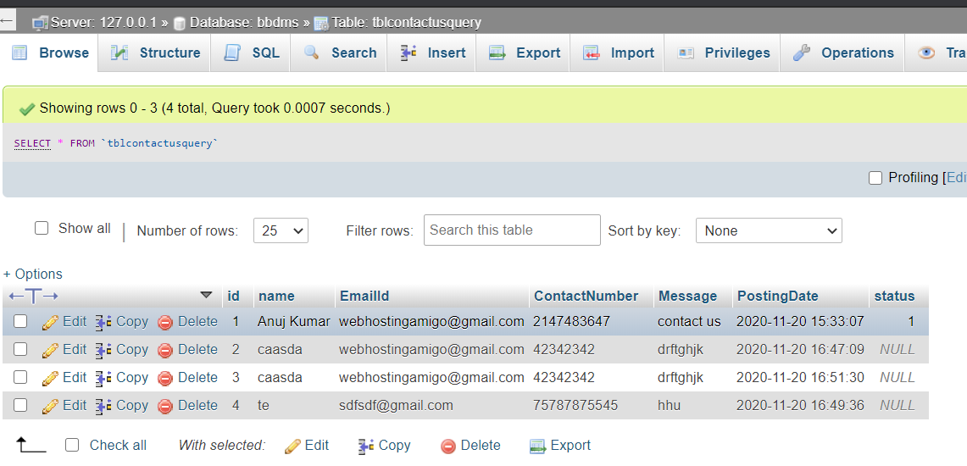

**Tblpages:**

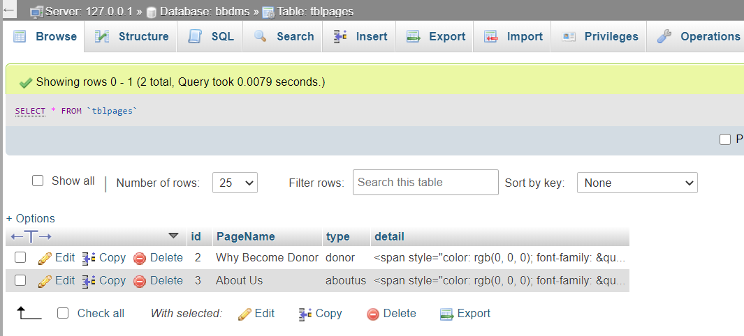

**Trigger :**

CREATE DEFINER=`root`@`localhost` TRIGGER `tblblooddonars’ AFTER INSERT ON `tblblooddonars` FOR EACH ROW INSERT INTO ‘tbltrigger’ VALUES(NEW.id,NEW.FullName,NEW.MobileNumber,NEW.EmailId,NEW.Gender,NEW.Age,NEW.BloodGroup,NEW.Address,NEW.Message,NEW.PostingDate,NEW.status);

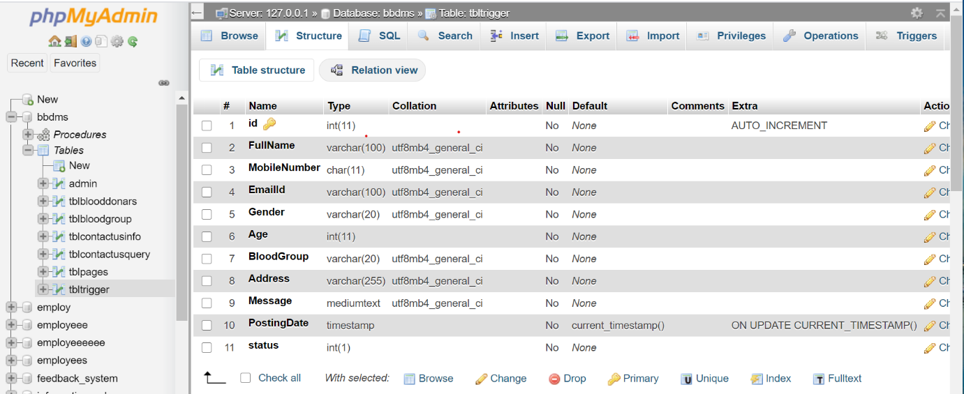

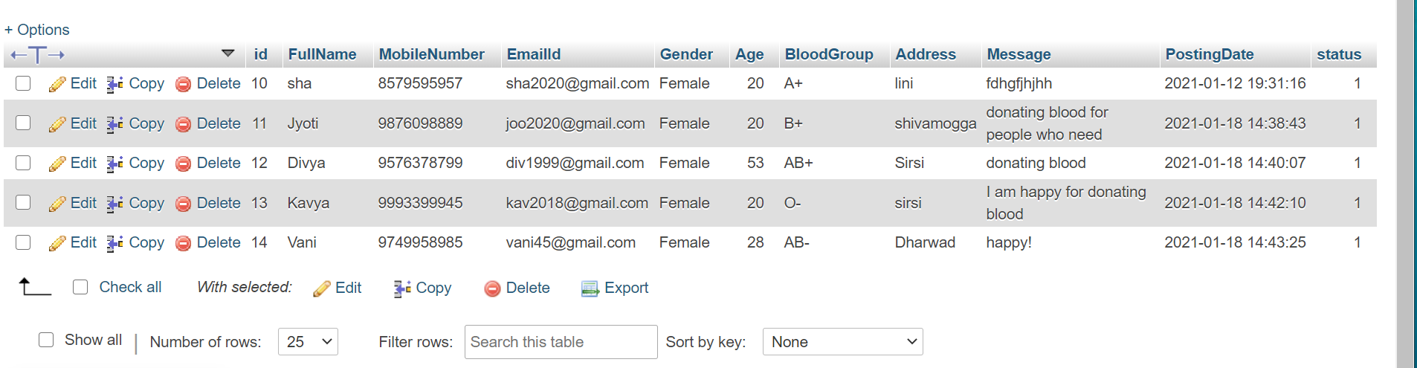

**Procedure used:**

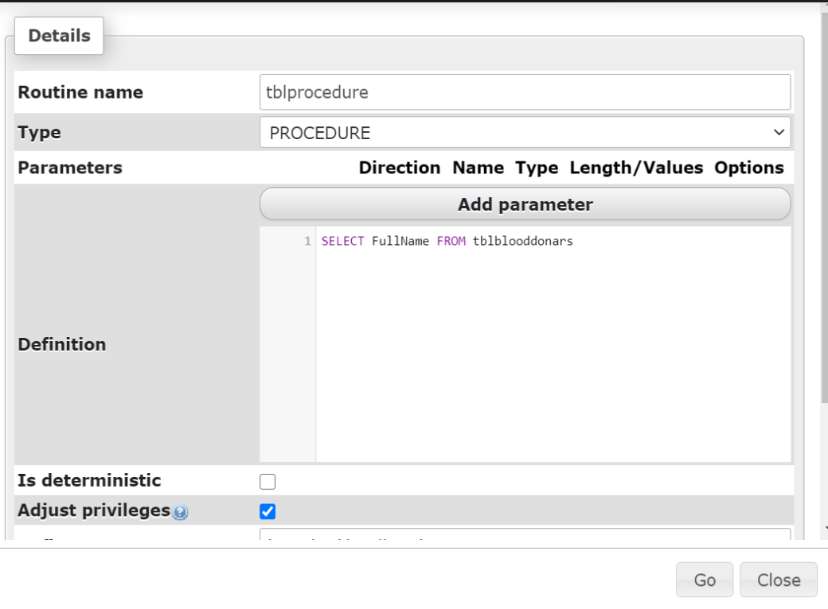

**Chapter 5**

**Result Snaps**

**Login page**

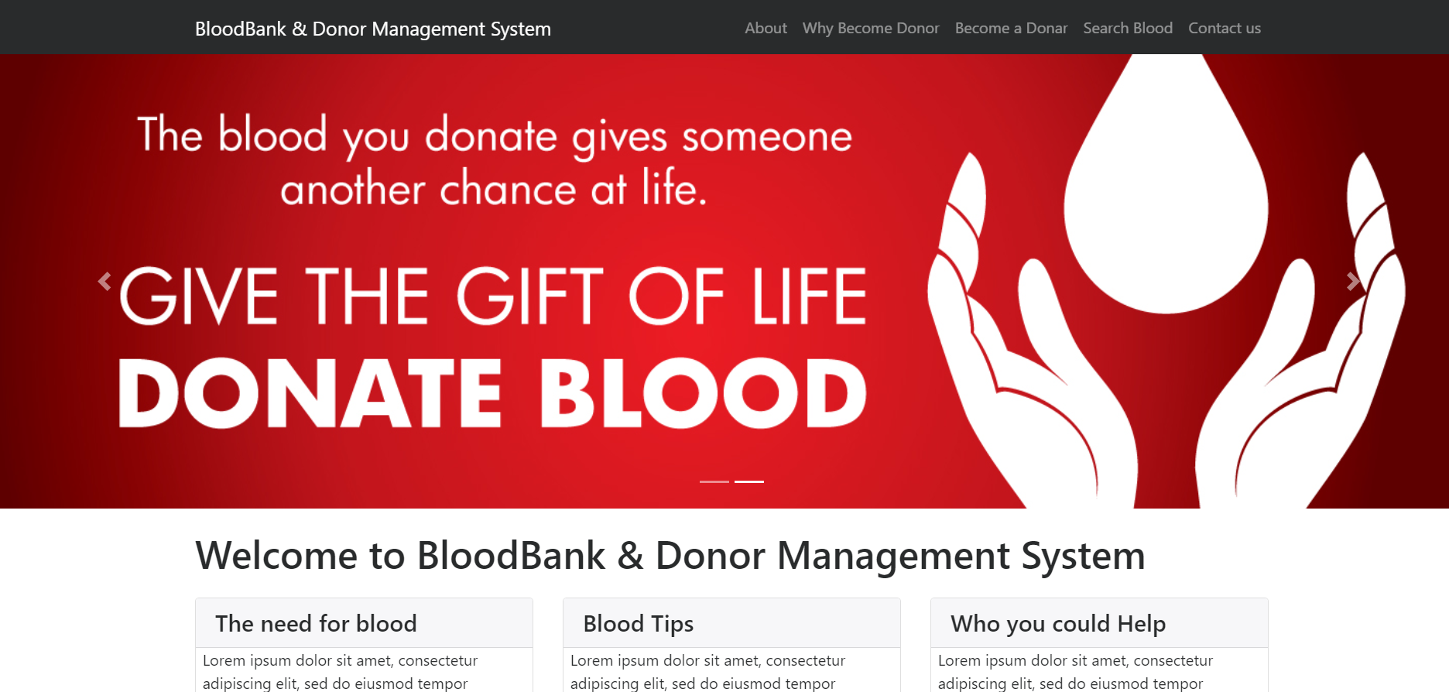

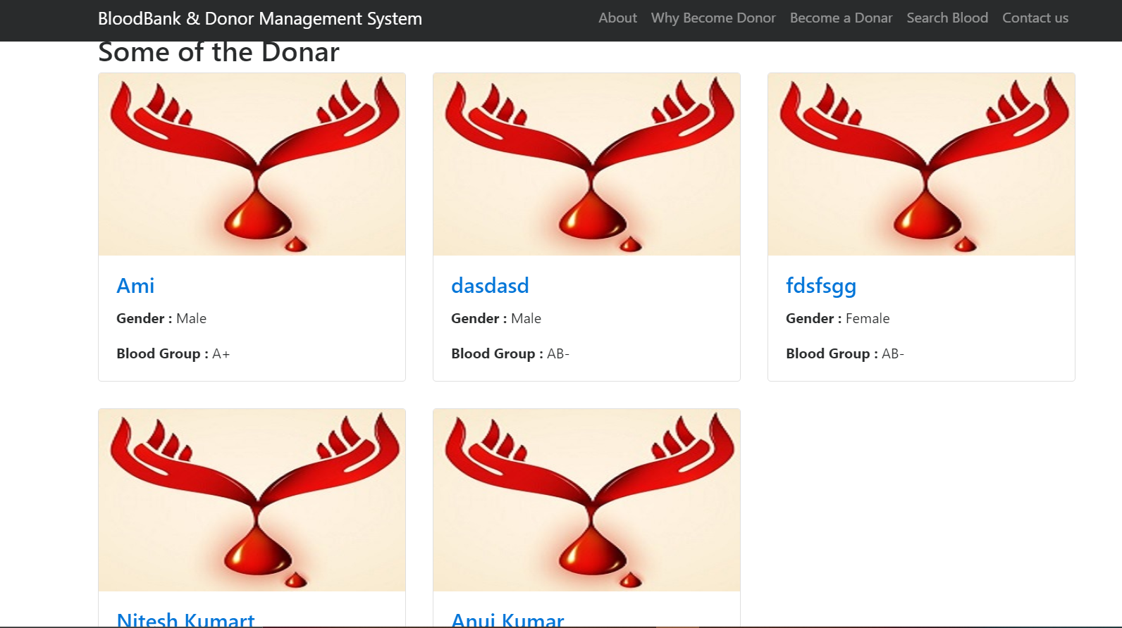

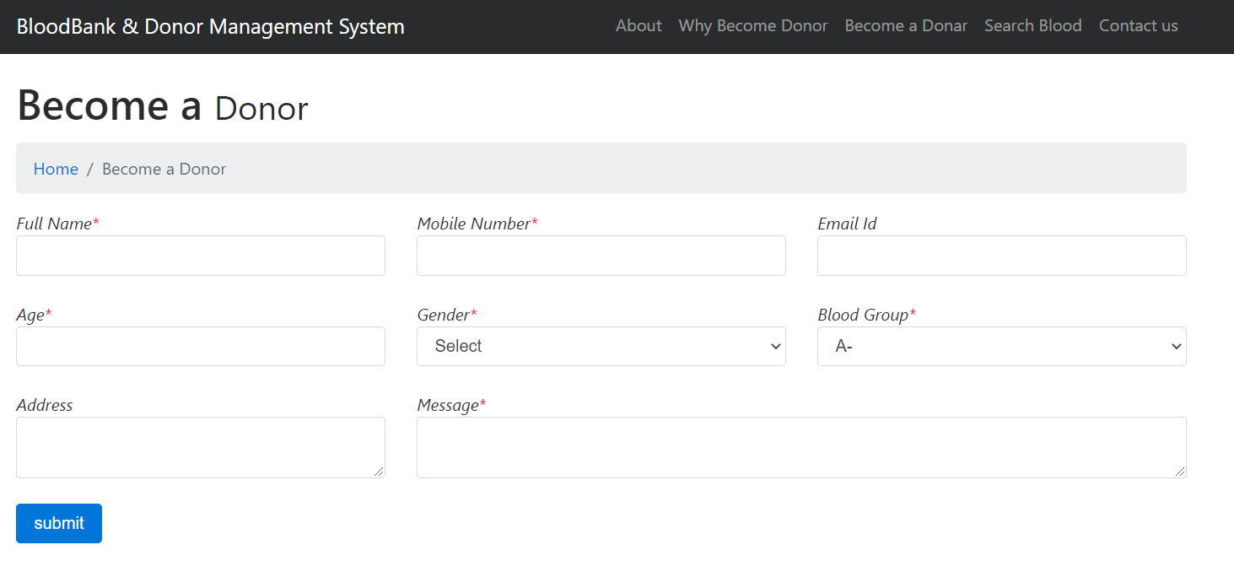

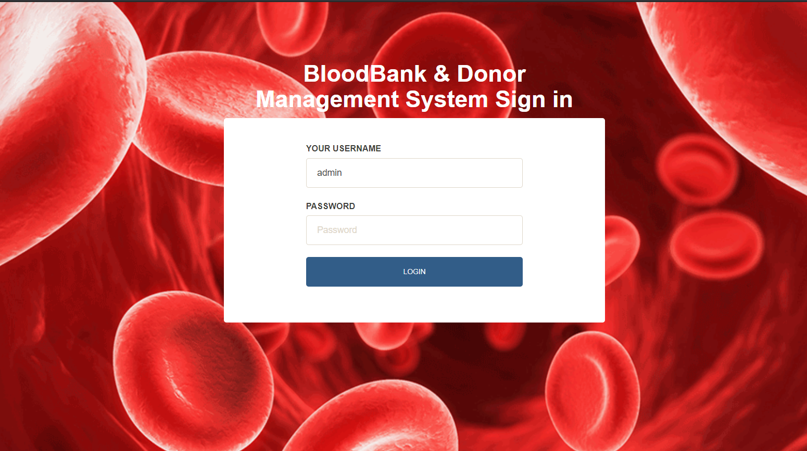

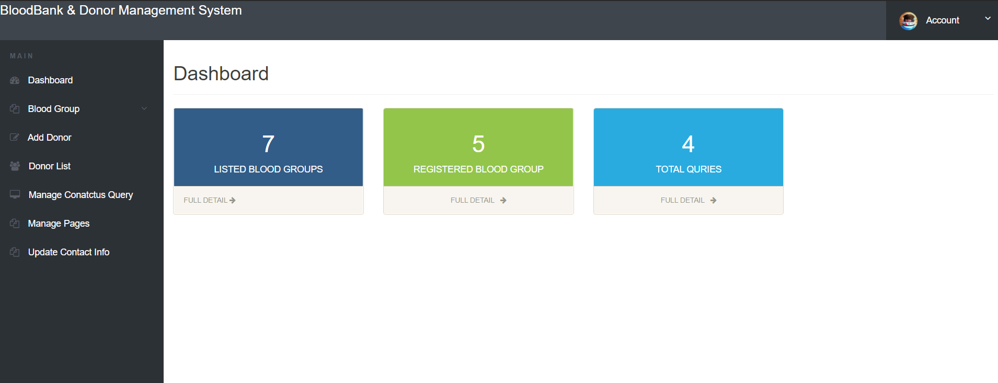

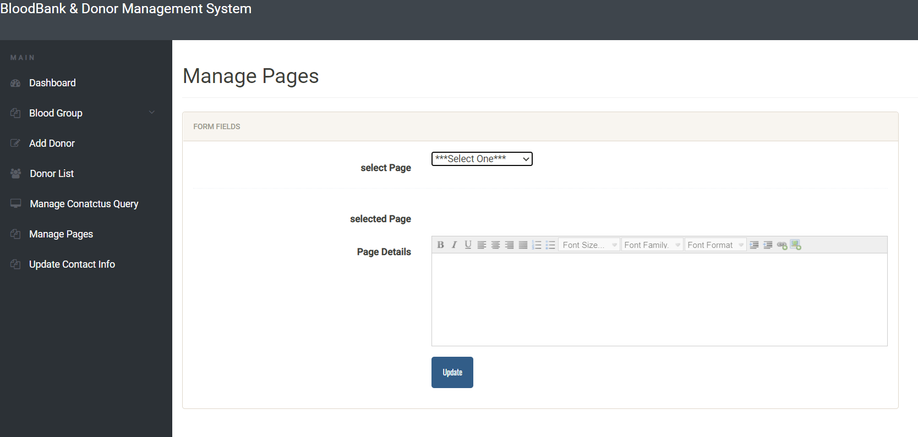

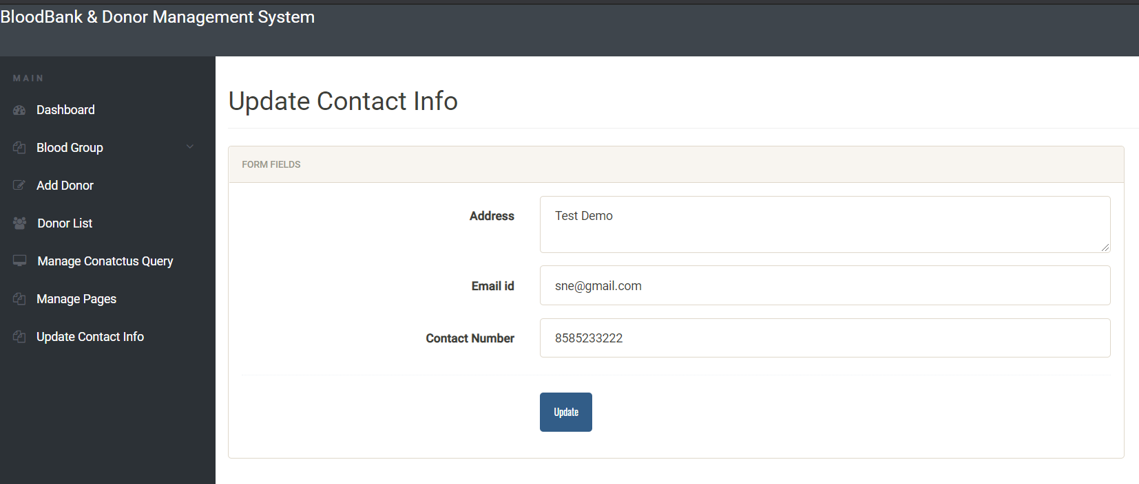

**Chapter 6**

**Conclusion**

**Outcome of this project**

**Login**: The system provides security features through username-password matching where only authorized user can access the system with different authorization level.

**Donor profile registration**: This allows healthy public to register as volunteer donor.

**Blood stock management**: the blood bank staffs can manage the blood stock starting from the blood collection, to blood screening, processing, storage, transference and transfusion through this system.